Multi AI Agent Systems with crewAI

Why we need multiagent
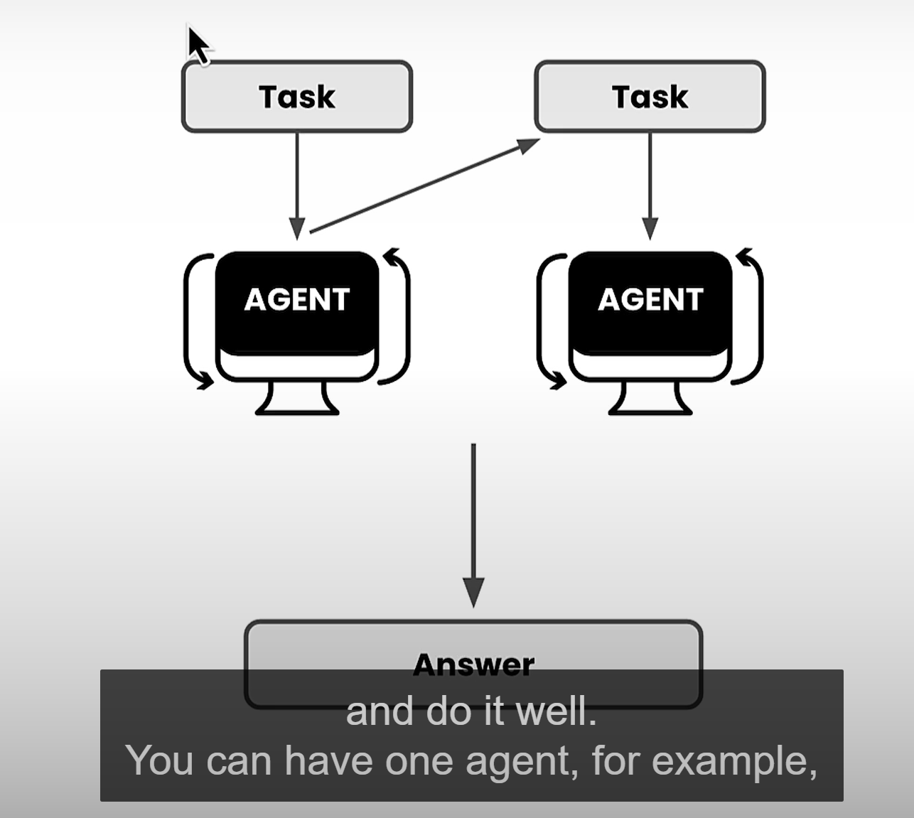

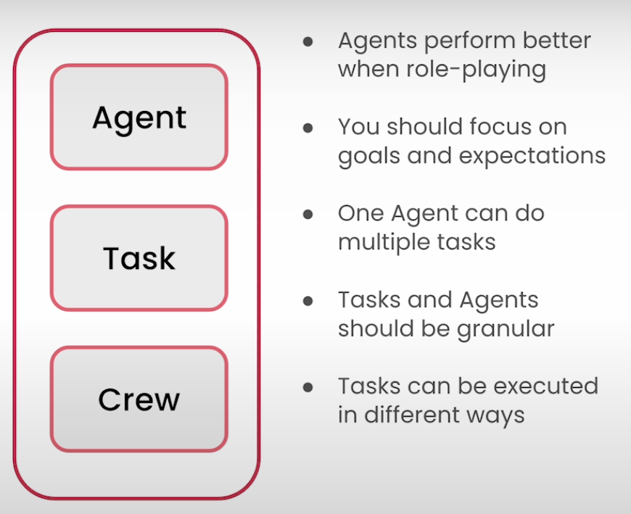
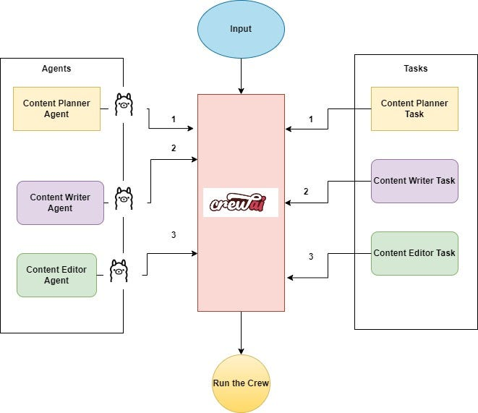
Multiagent Workflow using CrewAI and Ollama
Introduction
In technical terms an AI Agent is a software entity designed to perform tasks autonomously or semi-autonomously on behalf of a user or another program. These agents leverage artificial intelligence to make decisions, take actions, and interact with their environment or other systems. Some of the key characteristics of the Agents are as follows :
- Autonomy: AI agents operate without constant human intervention. They can perform tasks independently once they are given an objective.
- Decision-Making: They use algorithms, rules, and AI models to make decisions based on their perceptions and objectives. This includes evaluating different options and selecting the best course of action.
- Learning: Many AI agents incorporate machine learning techniques to improve their performance over time. They can learn from past experiences and adapt to new situations.
- Interaction: AI agents can communicate and collaborate with users, other agents, or systems. This interaction can involve natural language processing, sending and receiving data, or performing coordinated tasks.
- Specialization: AI agents can be specialized for specific tasks or domains. For instance, some agents might be designed for web browsing, while others might handle database interactions, perform complex calculations, or generate images.
- Goal-Oriented: AI agents are typically programmed with specific goals or objectives. They work towards achieving these goals through a sequence of actions and decisions.
In summary, AI agents are powerful tools that can automate and enhance a wide range of activities, from simple repetitive tasks to complex problem-solving scenarios, making them invaluable in various applications and industries.
Imagine harnessing all of the above concepts integrated together and all working together towards predefined goals to achieve desired results. These tasks could be executed in a sequential or hierarchical process, with all the agents working like a coordinated crew. This powerful collaboration can revolutionize how we approach complex problems, making processes more efficient and outcomes more effective. This is where The CrewAI framework comes into picture.
What is CrewAI?
CrewAi is a cutting-edge framework for orchestrating role-playing, autonomous AI agents. By fostering collaborative intelligence, CrewAI empowers agents to work together seamlessly, tackling complex tasks.
Core Concepts — CrewAI
- Agents: These are standalone units programmed to perform tasks , make decisions and communicate with other agents. They can use Tools which can be simple search functions or complex integrations involving other chains, APIs, etc.
- Tasks: Tasks are assignments or jobs that an AI agent needs to complete. They can include additional information like which agent should do it and what tools they might need.
- A Crew is a team of agents, each with a specific role, that work together to achieve a common goal. The process of forming a crew involves assembling agents, defining their tasks and establishing a sequence of task execution.
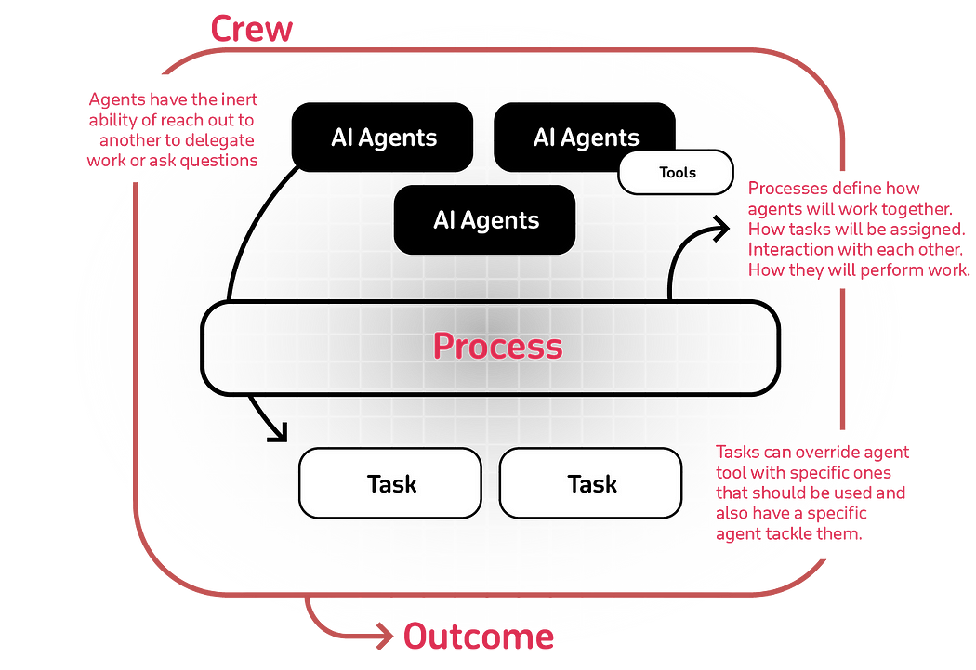
This article aims to offer a comprehensive overview of the CrewAI platform’s components through a CrewAI example.
What is Ollama ?
Ollama is an open-source app that lets you run, create, and share large language models locally with a command-line interface on MacOS ,Linux and windows.
Ollama has access to a wide range of LLMs directly available from their library, which can be downloaded using a single command. Once downloaded, you can start using it through a single command execution. This can be quite helpful for users whose workload revolves around a terminal window. If they are stuck somewhere, they can get an answer without switching to another browser window.
Features and Benefits
Here’s why OLLAMA is a must-have in your toolkit:
- Simplicity: OLLAMA offers a straightforward setup process. You don’t need a PhD in machine learning to get it up and running.
- Cost-Effectiveness: Running models locally means you’re not racking up cloud costs. Your wallet will thank you.
- Privacy: With OLLAMA, all data processing happens on your local machine. This is a big win for user privacy.
- Versatility: OLLAMA is not just for Python aficionados. Its flexibility allows it to be used in various applications, including web development.
LLM Selection using Ollama
By default Openai Models is used as llm in CrewAI. For peak performance with CrewAI crew, consider using GPT-4 or the slightly cheaper GPT-3.5 from OpenAI for your AI agents. These models are the backbone of your agents and significantly impact their capabilities
But here we will use Meta Llama 3,the most capable openly available LLM to date.Meta Llama 3, a family of models developed by Meta Inc. are new state-of-the-art , available in both 8B and 70B parameter sizes (pre-trained or instruction-tuned).
Llama 3 instruction-tuned models are fine-tuned and optimized for dialogue/chat use cases and outperform many of the available open-source chat models on common benchmarks.
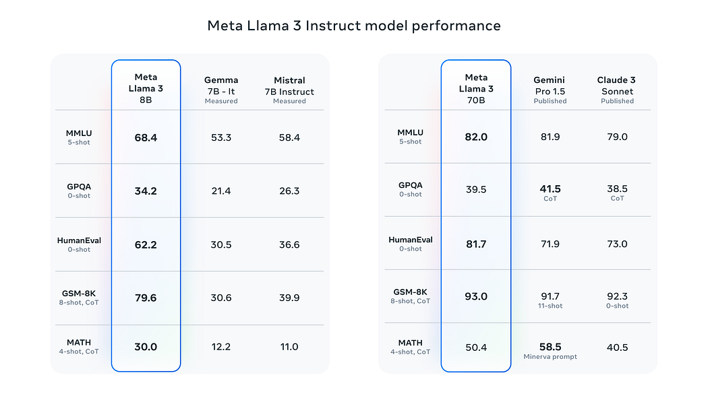
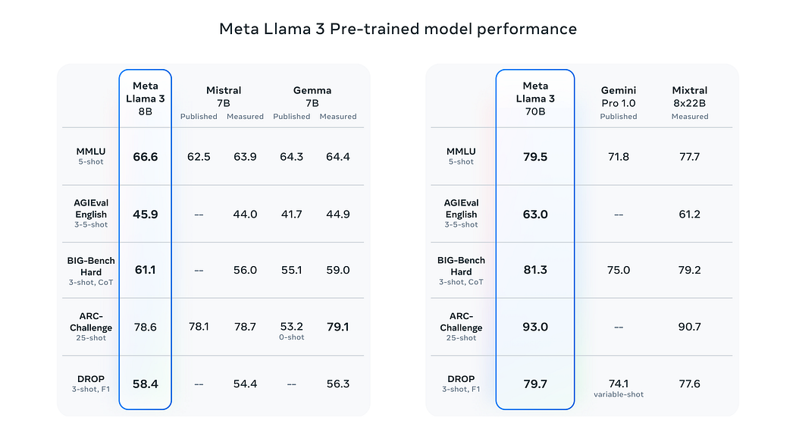

Imagine you are the manager
